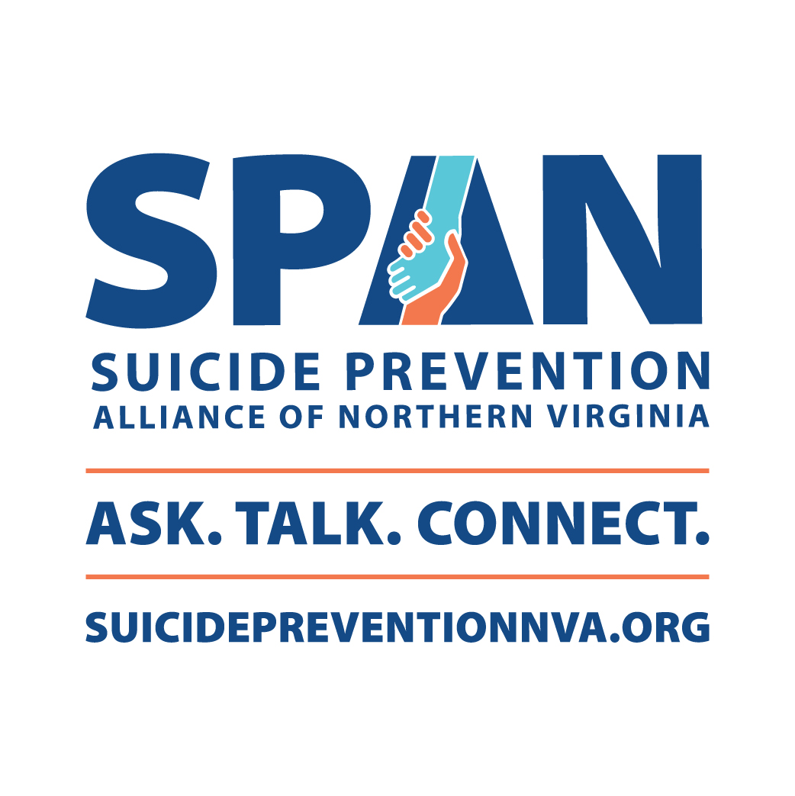

Partner Toolkit Spring 2023

**Introduction**

The Suicide Prevention Alliance of Northern Virginia (SPAN) is a regional coalition of the Alexandria, Arlington, Fairfax-Falls Church, Loudoun, and Prince William Community Services Boards (CSBs) and other partners in Northern Virginia, all working together to raise awareness and share resources to prevent suicide. SPAN and its partners convene, host, coordinate and inform people from all backgrounds to build our community's capacity to help prevent suicide. *You play a crucial role in helping to share this important information*. This toolkit was developed to help amplify our messages.

Messaging for SPAN focuses on two groups of people – individuals who are experiencing a mental health crisis themselves and others who may know someone in distress, as well as the community around them. SPAN wants everyone to know that resources and support are available, and to break down stigma by making conversations about mental health common. That’s why SPAN’s updated messaging theme is “**Ask. Talk. Connect.**”

Our messagetells individuals in distress it’s ok to **ask** for help and support, **talk** to those they trust, and **connect** with crisis or long-term mental health support services. At the same time, we want to encourage people in the community and loved ones to **ask** questions about suicide, **talk** openly about mental health and suicide prevention to help reduce stigma, and **connect** with trainings to learn skills and tools to have conversations about suicide and mental health.

This toolkit contains the following:

* + **Talking points** – This material highlights SPAN’s mission, addresses a few frequently asked questions, and shares ways to access resources and more information.
  + **Posters** – These materials feature three messages: one for signs and symptoms of a mental health crisis, one for people experiencing a mental health crisis, and one for loved ones or community members looking to support others. All three posters include a QR code for users to scan that directs them to the SPAN website. These posters can be printed and featured in stand-up table displays or hung up in public places. We encourage you to use and post these materials anywhere they may be seen.
  + **Editable Flyer** – This material can be edited to feature information from a unique event or organization and includes a place to put the partner organization’s logo. It can be printed or saved as a PDF and sent electronically.
  + **How to use the SPAN Logo**
  + **Social media copy and photobank** – This resource includes post copy and graphic options in two different sizes for Facebook, Twitter and Instagram. The posts raise awareness and encourage viewers to visit the SPAN website to find resources, tools, and support when talking about suicide and mental health. With a wide and diverse range of photos, pictures can be selected based on what makes sense for your audience.

Thank you for communicating SPAN’s mission to prevent suicide in Northern Virginia – and for your dedication to help educate, inform, and support suicide prevention efforts.

**Background**

**About SPAN**

The **Suicide Prevention Alliance of Northern Virginia (SPAN)** is a regional coalition of the Alexandria, Arlington, Fairfax-Falls Church, Loudoun, and Prince William Community Services Boards (CSBs) and community partners, all working together to raise awareness and share resources to prevent suicide.

SPAN partners include the Virginia Department of Behavioral Health and Developmental Services, local health departments, school systems, non-profit organizations and community members across Northern Virginia.

Through our network, we offer connections to information, training, and other resources to prevent suicide in our community. You can connect to these resources through our website, [SuicidePreventionNVA.org](http://www.suicidepreventionnva.org/).

**SPAN’s Offerings**

Through our website and our network of partners, you can:

* Learn more about mental health – from the warning signs of a mental health crisis to tips for starting a conversation that could save a life.
* Find local support and mental health resources for someone in need.
* Learn how to talk about suicide and mental health so we can reduce the stigma around seeking help.
* Connect to support after a suicide loss in your community.
* Find local trainings and resources about suicide prevention.

**Why Talk About Suicide?**

All of us have a responsibility to support the mental health of our community members. Death by suicide is a public health crisis throughout the nation, and Virginia is no exception. According to data from the CDC, 45,979 people died by suicide in the U.S. in 2020. Another 1.2 million adults attempted suicide. In Virginia, more than 1,200 people died by suicide.

Certain groups are at higher risk. For example, high school students who identify as LGBTQ+ are 4 times as likely to attempt suicide than their peers. There is also a growing suicide crisis among young people: Suicide is the second leading cause of death for people ages 15–24.

Other groups who are at higher risk of suicide include veterans, older adults, and people with disabilities.

Together, we can make a difference in our community. We can start by educating ourselves about the known risk factors for suicide and what can help a person in crisis. Knowledge and understanding about mental health challenges also reduces the stigma associated with reaching out for help. The fear of encountering stigma remains one of the biggest barriers to seeking help. By raising awareness, and making these conversations commonplace, we can all help save lives.

If you have lost a loved one to suicide, it can be devastating. But you are not alone, there is help. There are many local support groups to connect with throughout Northern Virginia.

**Talking Points**

**What Can I Do?**

If you’re having a mental health crisis or know someone who is, know that it’s OK to not be OK. It can be tough, but it is OK to ask for help. If you or someone you know is experiencing a mental health crisis, **call or text 988 to reach the national Suicide & Crisis Lifeline** and talk with a trained counselor. The 988 lifeline is free, confidential, and available 24/7.

**Educate yourself**

* Take a class or attend a workshop
* Get to know the warning signs that someone might be struggling with their mental health, some of which are:
  + Significant changes in mood or behavior
  + Becoming withdrawn or isolated from friends and family
  + Increased use of drugs or alcohol
  + Talking about feeling trapped, hopeless, or in unbearable pain
* Talk about mental health with your friends, neighbors and coworkers

**Raise awareness**

* Host an event in your community (an editable poster is included in this toolkit)
* Post messages on your personal or organization’s social media networks (see possible messages included in this toolkit)
* Post flyers around your community, school, workplace, faith centers or anywhere people congregate (included in this toolkit)

**Speak up** if you think someone is in crisis. You can start a conversation that could save a life.

* Ask: How are you doing? Are you thinking about suicide? How can I help?
* Talk: Support them in person or on the phone. Follow up once they are safe.
* Connect: Call 988 to help them find support and talk with a trained counselor.

You can learn more about how to support mental health in your community at SPAN’s website: [SuicidePreventionNVA.org](http://www.suicidepreventionnva.org/).

**Posters**

**Poster 1 – Know the Warning Signs**

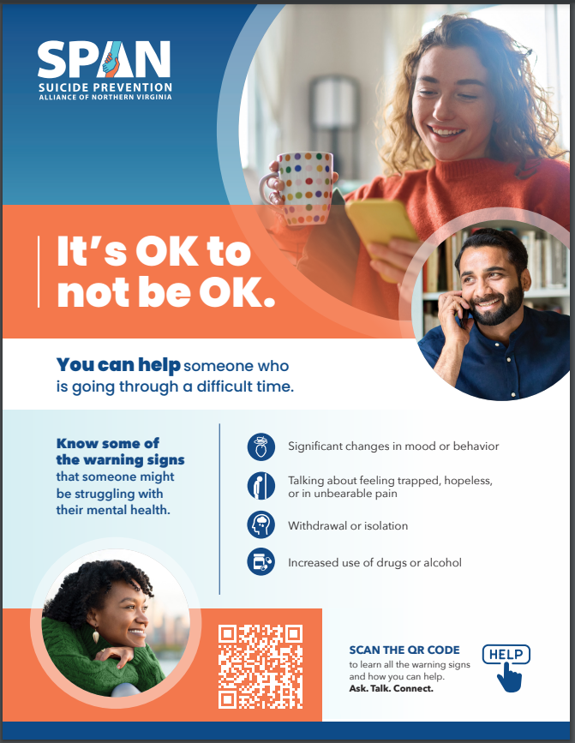

**Poster 2 – Resources for Those in Crisis**

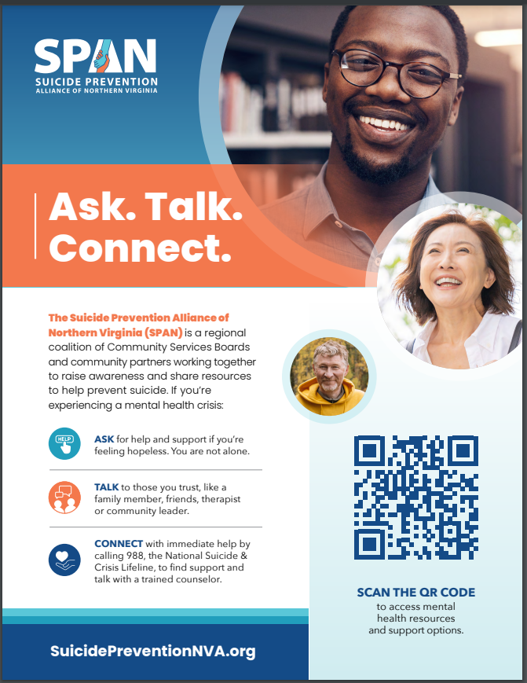

**Poster 3 – Resources for Loved Ones & Community Members**

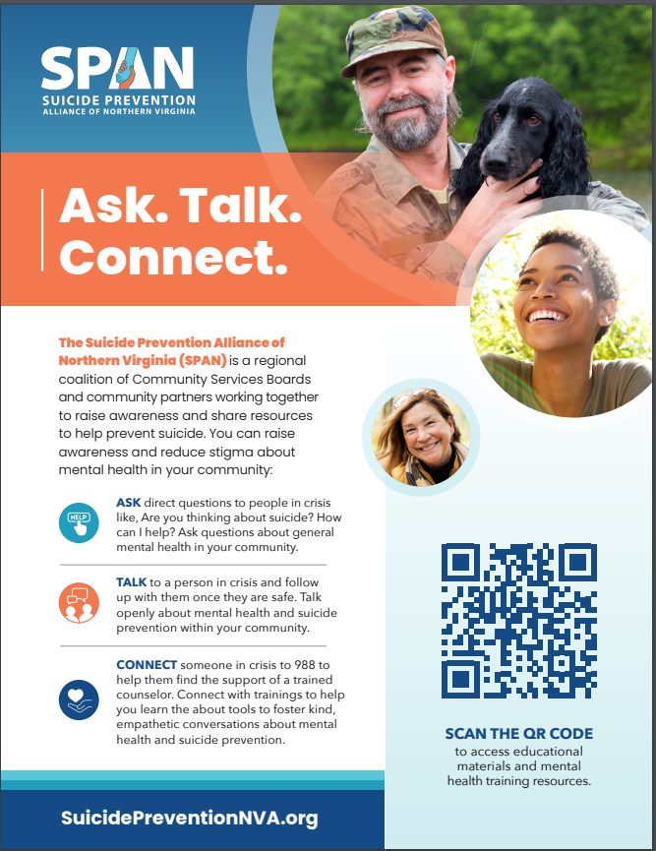

**Editable flyer – use this flyer to promote your own event or activity**

**Rachel's edits
**

**SPAN Logo Usage**

**Social Media Content**

|  |
| --- |
| **Social media graphics and accompanying copy will promote SPAN resources. Images to use can be found in the attached photo bank and used interchangeably to best capture the intended audience.** |

| **Post** | **Twitter Copy** | **Facebook Copy** | **Instagram Copy** | **Media Asset** |
| --- | --- | --- | --- | --- |
| 1 – Overview of SPAN | SPAN is raising awareness and sharing resources to help prevent suicide. Learn more about mental health, find information that could help someone in need, connect to support after a suicide loss, and find trainings and suicide prevention resources at SuicidePreventionNVA.org | SPAN is raising awareness and sharing resources to help prevent suicide. Learn more about mental health, find information that could help someone in need, connect to support after a suicide loss, and find trainings and suicide prevention resources at SuicidePreventionNVA.org | SPAN is raising awareness and sharing resources to help prevent suicide. Learn more about mental health, find information that could help someone in need, connect to support after a suicide loss, and find trainings and suicide prevention resources at SuicidePreventionNVA.org | Choose an image from the photo bank that best matches your intended audience. |
| 2 – For People in Crisis | Have you noticed changes in your mood? Are you feeling hopeless or lost? It’s OK to ask for help. If you’re struggling with your mental health or going through a difficult time, help is available. Find resources and ways to connect with support: SuicidePreventionNVA.org | Have you noticed changes in your mood? Are you feeling hopeless or lost? It’s OK to ask for help. If you’re struggling with your mental health or going through a difficult time, help is just a call, text, or click away. Find resources and ways to connect with support: SuicidePreventionNVA.org | Have you noticed changes in your mood? Are you feeling hopeless or lost? It’s OK to ask for help. If you’re struggling with your mental health or going through a difficult time, help is just a call, text, or click away. Find resources and ways to connect with support at SuicidePreventionNVA.org | Choose an image from the photo bank that best matches your intended audience. |
| 3 – Support Mental Health & Prevent Suicide in Your Community | Know the signs someone in your community might be struggling with their mental health: extreme mood swings, withdrawal or isolation, increased use of drugs or alcohol, or talking about feeling trapped or hopeless. Learn more about what to look for at SuicidePreventionNVA.org. | Know the signs someone in your community might be struggling with their mental health: extreme mood swings, withdrawal or isolation, increased use of drugs or alcohol, or talking about feeling trapped, hopeless, or in unbearable pain. Learn more about what to look for at SuicidePreventionNVA.org. | Know the signs someone in your community might be struggling with their mental health: extreme mood swings, withdrawal or isolation, increased use of drugs or alcohol, or talking about feeling trapped, hopeless, or in unbearable pain. Learn more about what to look for at SuicidePreventionNVA.org. | Choose an image from the photo bank that best matches your intended audience. |
| 4 – Support After a Suicide Loss | If you lost a loved one to suicide, you are not alone. There is help. Find resources and ways to connect with support at SuicidePreventionNVA.org | If you lost a loved one to suicide, you are not alone. There is help. Find resources and ways to connect with support at SuicidePreventionNVA.org | If you lost a loved one to suicide, you are not alone. There is help. Find resources and ways to connect with support at  SuicidePreventionNVA.org | Choose an image from the photo bank that best matches your intended audience. |